is | am | are

Напиши предложения по образцу.
Образец.
 |  | Вопрос | Ответ
 | you | 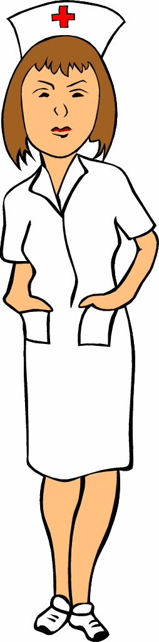 | 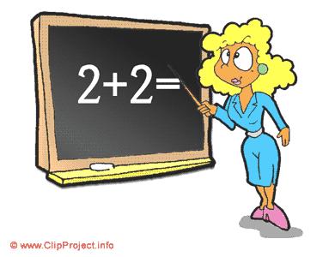
Are you a doctor? No, I am not.
 | Nick and Dick | 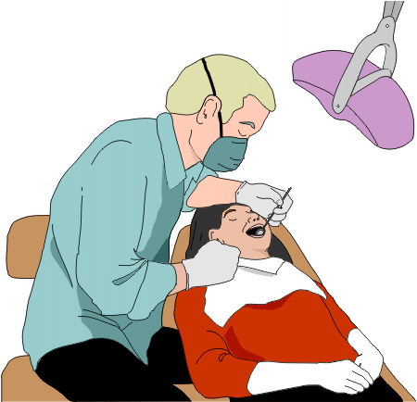
Are Nick and Dick dentists? Yes, they are.

1 | Fred | 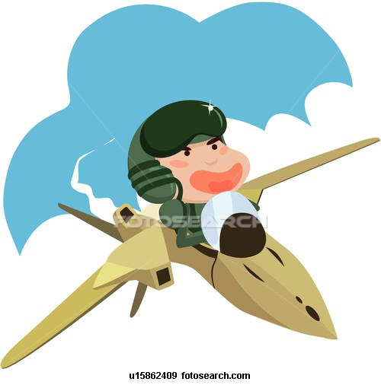
2 | we |  | 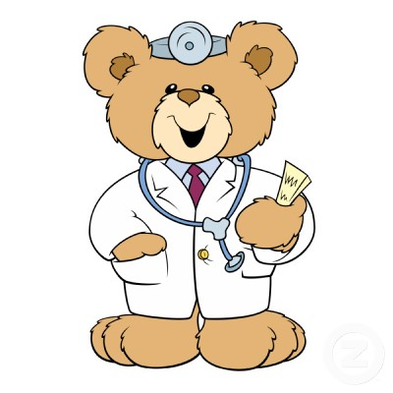
3 | Tim and Tom | 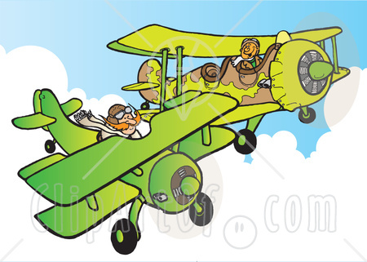
4 | you | 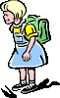
5 | Ann | 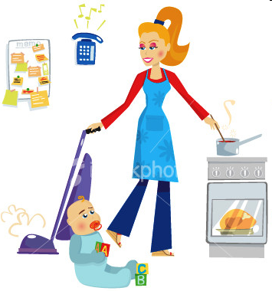
6 | Ben |  | 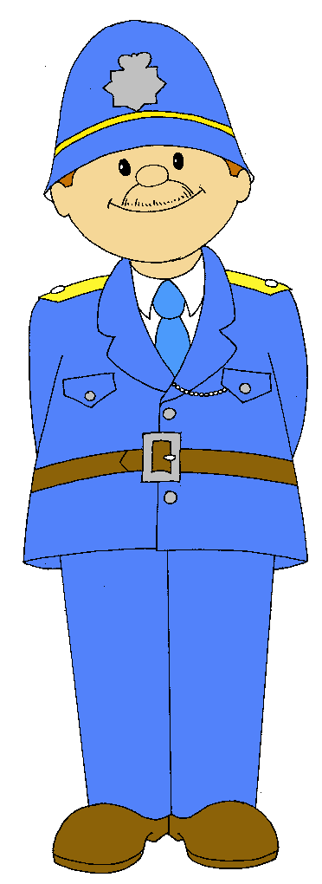
7 | Mary and Ann | 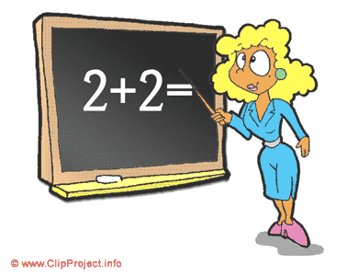
8 | you
9 | Pat and Bob | 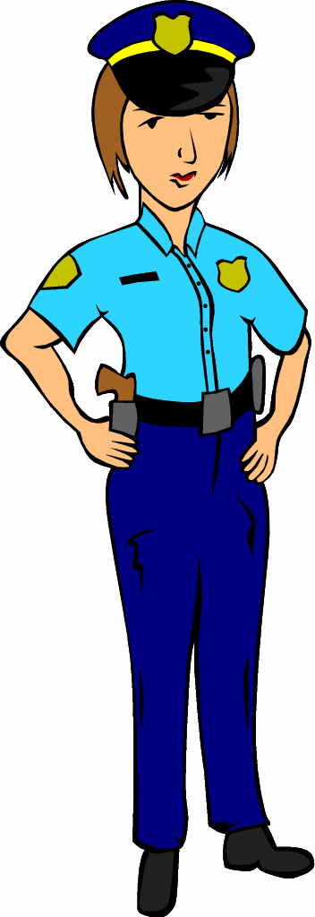
10 | Kate |  | 

